Solution Architecture Design Document (SAD)
Project Title
Global Serverless Media Streaming & Personalization Platform on (AWS)
1. Document Control
- Version: 1.0
- Cloud Platform: Amazon Web Services (AWS)
- Architecture Type: Serverless, Event-Driven, Multi-Region
- Intended Audience: Solution Architects, Cloud Engineers, Technical Stakeholders

2. Executive Summary
OmniStream is a cloud-native, serverless media streaming platform designed on AWS to ingest, process, distribute, and personalize video and audio content at global scale. The solution leverages managed AWS services to achieve high availability, low latency, strong security, and cost efficiency while minimizing operational overhead.
The architecture supports web, mobile, and smart TV clients, integrates AI-driven personalization and media intelligence, and follows AWS Well-Architected Framework principles.

3. Business Objectives
- Enable scalable ingestion and processing of media content
- Deliver low-latency global streaming experiences
- Personalize content recommendations per user
- Secure user access and content delivery
- Provide actionable analytics on user engagement
- Minimize infrastructure management and operational cost

4. Non-Functional Requirements
Category | Requirement
Scalability | Automatic scaling for ingestion, processing, and delivery
Availability | Multi-AZ and global CDN distribution
Security | IAM, Cognito authentication, signed URLs
Performance | Low-latency streaming via CloudFront
Cost | Serverless, pay-per-use model
Observability | Centralized logging, metrics, and dashboards

5. High-Level Architecture Overview
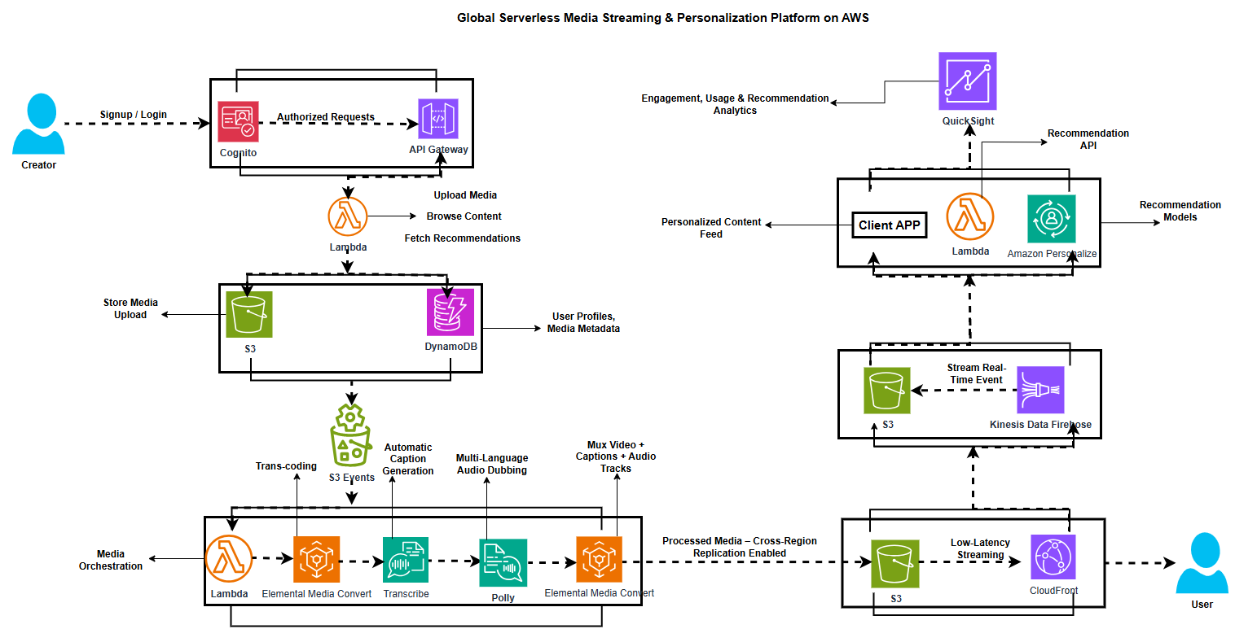
The solution follows a serverless, event-driven architecture using Amazon S3 events, AWS Lambda, and managed AI/ML services. Media is processed asynchronously and delivered globally using Amazon CloudFront.

6. Detailed Architecture Flow
6.1 Client Access & Authentication
- Client applications authenticate using Amazon Cognito
- Cognito issues JWT tokens with role-based access claims
- Amazon API Gateway validates tokens using a Cognito Authorizer
6.2 Media Upload & Metadata Management
- Authenticated users upload media via API Gateway
- Raw media is stored in Amazon S3 (Raw Media Bucket)
- Media metadata and user profiles are stored in Amazon DynamoDB
6.3 Event-Driven Media Processing
- S3 upload events trigger AWS Lambda (Media Orchestration)
- Lambda submits transcoding jobs to AWS Elemental MediaConvert
- Media is transcoded into multi-bitrate formats
6.4 AI Media Enhancements
- Amazon Transcribe generates captions and subtitles
- Amazon Polly produces multi-language audio tracks
- MediaConvert muxes video, captions, and audio tracks
6.5 Global Content Delivery
- Processed media is stored in Amazon S3 (CRR-enabled)
- Amazon CloudFront distributes content globally
- Signed URLs and cookies enforce secure access
6.6 User Engagement Tracking & Analytics
- Client applications emit interaction events
- Events are ingested via Amazon Kinesis Data Firehose
- Data is stored in Amazon S3 and optionally Amazon Redshift
- Amazon QuickSight visualizes engagement metrics
6.7 Personalization Engine
- Interaction data is fed into Amazon Personalize
- ML models generate per-user content recommendations
- AWS Lambda (Recommendations API) serves personalized feeds

7. Security Architecture
- Amazon Cognito for authentication and RBAC
- IAM least-privilege policies
- Encrypted S3 buckets (SSE-S3 / SSE-KMS)
- HTTPS enforced across all endpoints
- Signed CloudFront URLs for content protection

8. Multi-Region & Resilience Strategy
Layer | Strategy
Storage | S3 Cross-Region Replication
Delivery | CloudFront global edge network
Compute | Lambda multi-AZ execution
DNS | Route 53 latency-based routing

9. Cost Optimization Considerations
- Serverless services reduce idle cost
- S3 lifecycle policies for archival
- CloudFront caching to reduce origin load
- Firehose batching to optimize ingestion cost

10. Alignment with AWS Well-Architected Framework
- Operational Excellence: Managed services, automation
- Security: Identity-centric design, encryption
- Reliability: Event-driven, decoupled components
- Performance Efficiency: CDN, auto-scaling
- Cost Optimization: Pay-per-use, no idle servers

11. Assumptions & Constraints
- Design-only; no production deployment
- Media DRM not implemented in initial phase
- Focus on architecture clarity over implementation detail

12. Conclusion
OmniStream demonstrates a production-grade, cloud-native media streaming architecture on AWS, showcasing best practices in serverless design, AI integration, global delivery, and personalization. The solution is suitable as both a real-world blueprint and a Solution Architect portfolio project.

